Semester 1 Examination, 2010

Question/Answer Booklet

MATHEMATICS 2A
Section Two:
Calculator-assumed

Time allowed for this section
Reading time before commencing work: 10 minutes
Working time for this section: 100 minutes

Material required/recommended for this section

To be provided by the supervisor
This Question/Answer Booklet
Formula Sheet (retained from Section One)

To be provided by the candidate
Standard items: pens, pencils, pencil sharpener, eraser, correction fluid, ruler, highlighters

Special items: drawing instruments, templates, notes on two unfolded sheets of A4 paper, and up to three calculators satisfying the conditions set by the Curriculum Council for this course.

Important note to candidates
No other items may be taken into the examination room. It is your responsibility to ensure that you do not have any unauthorised notes or other items of a non-personal nature in the examination room. If you have any unauthorised material with you, hand it to the supervisor before reading any further.

Structure of this paper

Section | Number of questions available | Number of questions to be answered | Suggested working time  (minutes) | Marks available
Section One:  Calculator-free | 7 | 7 | 50 | 40
Section Two:  Calculator-assumed | 11 | 11 | 100 | 80
 |  |  |  | 120

Instructions to candidates

1. Write your answers in the spaces provided in this Question/Answer Booklet. Spare pages are included at the end of this booklet. They can be used for planning your responses and/or as additional space if required to continue an answer.
  - Planning: If you use the spare pages for planning, indicate this clearly at the top of the page.
  - Continuing an answer: If you need to use the space to continue an answer, indicate in the original answer space where the answer is continued, i.e. give the page number. Fill in the number of the question(s) that you are continuing to answer at the top of the page.

2. Show all your working clearly. Your working should be in sufficient detail to allow your answers to be checked readily and for marks to be awarded for reasoning. Incorrect answers given without supporting reasoning cannot be allocated any marks. For any question or part question worth more than two marks, valid working or justification is required to receive full marks. If you repeat an answer to any question, ensure that you cancel the answer you do not wish to have marked.

3. It is recommended that you do not use pencil except in diagrams and graphs.
USE BLUE OR BLACK PEN.

Question number | Marks available | Marks awarded
8 | 3
9 | 7
10 | 6
11 | 10
12 | 5
13 | 10
14 | 8
15 | 8
16 | 5
17 | 9
18 | 9
Total | 80

Section Two: Calculator-assumed (80 Marks)

This section has eleven (11) questions. Answer all questions. Write your answers in the space provided.

Spare pages are included at the end of this booklet. They can be used for planning your responses and/or as additional space if required to continue an answer.
  - Planning: If you use the spare pages for planning, indicate this clearly at the top of the page.
  - Continuing an answer: If you need to use the space to continue an answer, indicate in the original answer space where the answer is continued, i.e. give the page number. Fill in the number of the question(s) that you are continuing to answer at the top of the page.

Suggested working time for this section is 100 minutes.

Question 8 (3 marks)

(a) Julie and her friend Vina are on holiday in Thailand. The hotel where they are staying will change their Australian currency into Thai baht (the Thai currency unit) without charging any additional fees. Julie buys 5000 baht. This costs her $223.20. Vina wants to buy 7000 baht.

What will this cost Vina in Australian dollars? (1 mark)

(b) In a game of beach soccer, Stephanie (S) is 5.2 metres directly in front of the left hand goal post (L). She is 6.4 metres away from the right hand goal post (R), as shown in the diagram below. How far apart are the goal posts, giving your answer in metres correct to one decimal place? (2 marks)
R
L
S

Question 9 (7 marks)

(a) Pablo wants to buy 1 kg of instant coffee for a group of mates who are going on a camping trip. At the supermarket he finds that the preferred fair-trade coffee comes in three packs of different weights:
500 g for $28.22, 250 g for $11.54, and 200 g for $9.82.
What is the cheapest way for Pablo to buy 1 kg of fair-trade instant coffee? (3 marks)

(b) A brand of toothpaste is sold in two sizes, 120 g tubes costing $2.91 and 160 g tubes costing $3.41.

(i) Calculate the price per 100 g of each size tube and decide which is the better buy (2 marks)

(ii) The manufacturers wish to introduce a 200 g tube that is to be a better buy than the 160 g tube. What is the maximum they can charge for the 200 g tube?
(2 marks)

Question 10 (6 marks)

Consider the following shapes
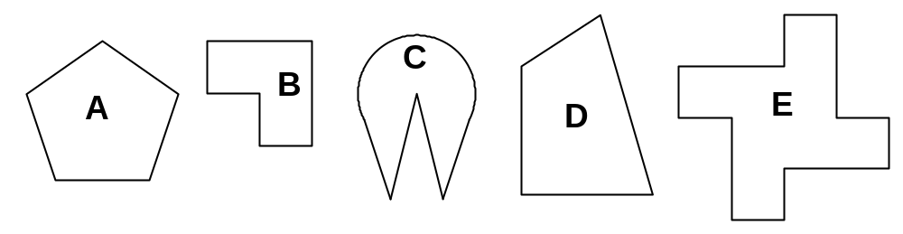
(a) Complete this table for the shapes (3 marks)

Shape | A | B | C | D | E
Number of lines of symmetry
Order of rotational symmetry

(b) Which of these shapes tessellate? (1 mark)

(c) Select one of the tessellating shapes and draw a neat sketch showing the tessellation of at least two repeats to the right and another row below. (2 mark)


Question 11 (10 marks)

(a) Determine the values of , , and so that the data set:

(i) 0, 1, 3, 7, 10, has a mean of 4 (1 mark)

(ii) 0, 1, 3, 7, 10, has a median of 3.5 (1 mark)

(iii) 0, 1, 3, 7, 10, has a range of 20 (1 mark)

(b) The coach of the school swimming team records the number of laps each team member swims at training sessions. The data for training last Thursday is shown in the table.

Number of laps | 11 | 14 | 15 | 16 | 17 | Total
Frequency | 1 | 4 | 7 | 6 | 3
Relative frequency

(i) Complete the frequency table. (1 mark)

(ii) How many members of the swim team trained last Thursday? (1 mark)

(iii) What fraction of the team swum the median number of laps on Thursday?
(2 mark)

(iv) What percentage of the team swam the maximum number of laps? (1 mark)

(v) Without drawing the graph, describe the spread of the data using appropriate statistics and terms. (2 marks)

Question 12 (5 marks)

The number of children per family was recorded for all residents of Windyup who were made homeless after heavy floods. The results are displayed in the table below.

Number of children in family | frequency
0 | 15
1 | 10
2 | 22
3 | 25
4 | 10
5 | 6
6 | 0
7 | 1

Use the data in the table for the following calculations.

(a) How many children in Windyup were made homeless? (1 mark)

(b) What was the modal number of children per family? (1 mark)

(c) What was the mean number of children per family? (1 mark)

(d) What was the median number of children per family? (1 mark)

(e) The relief authorities would like to keep families together. They plan temporary housing for each family. Which measure would be the most appropriate to use for them to use for their planning?
Explain your reasoning. (1 marks)

Question 13 (10 marks)

An insurance company statistician studied the causes of car accidents over a period of one year. One of the variables she recorded was the age of the driver involved in serious accidents.

The information was recorded as follows:

Age in years | 18 ≤ a < 23 | 23 ≤ h < 28 | 28 ≤ h < 33 | 33 ≤ h < 38 | 38 ≤ h < 43
Number of drivers | 10 | 8 | 3 | 3 | 1
Age in years | 43 ≤ h < 48 | 48 ≤ h < 53 | 53 ≤ h < 58 | 58 ≤ h < 63 | 63 ≤ h < 68
Number of drivers | 3 | 1 | 4 | 5 | 7

(a) Use the class midpoints to calculate the mean age of drivers (correct to two decimal places). (2 marks)

(b) Find the median class interval (the interval which contains the median). (1 mark)

(c) State the modal class interval. (1 mark)

(d) Draw a sketch of the frequency histogram (not to scale) and briefly describe the spread of the data.
(3 marks)

(e) What conclusions could the statistician make from studying the data?
(3 marks)

Question 14 (8 marks)

(a) (i) Plot the points A(-2, -2) and B(1, 4) on the axes below. Label these. (1 mark)
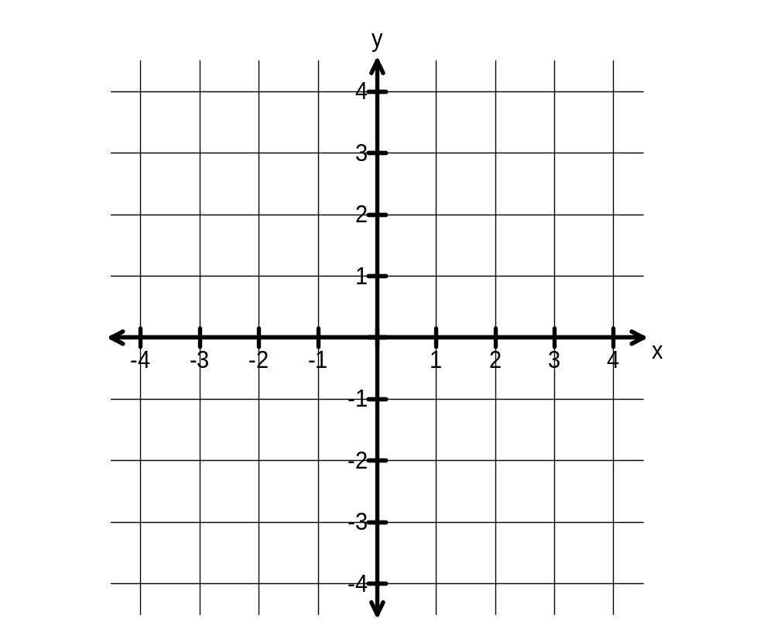

(ii) On the graph above, draw in the line that passes through points A and B.
(1 mark)

(iii) What is the gradient of the line through points A and B? (1 mark)

(iv) Write the equation of the line through points A and B in the form
(1 mark)

(b) On the same axes, draw and label the line 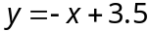 (2 marks)

(c) Show algebraically that the point (0.5, 3) lies on the line through the points A and B.
(2 marks)

Question 15 (8 marks)

Fiona is training for an endurance race. She decides to follow a training program over several weeks. Fiona decides to increase the total distance she runs each day by a constant number of metres. The distances for the first four days of this training program are shown in the table.

Day | 1 | 2 | 3 | 4
Distance (km) | 3.2 | 3.5 | 3.8 | 4.1

(a) What distance will Fiona run on Day 6? (1 mark)

(b) On which day will Fiona first run more than 6 kilometres? (1 mark)

(c) Draw a graph of the distances run by Fiona from day 1 to day 8 on the axes below.
(2 marks)

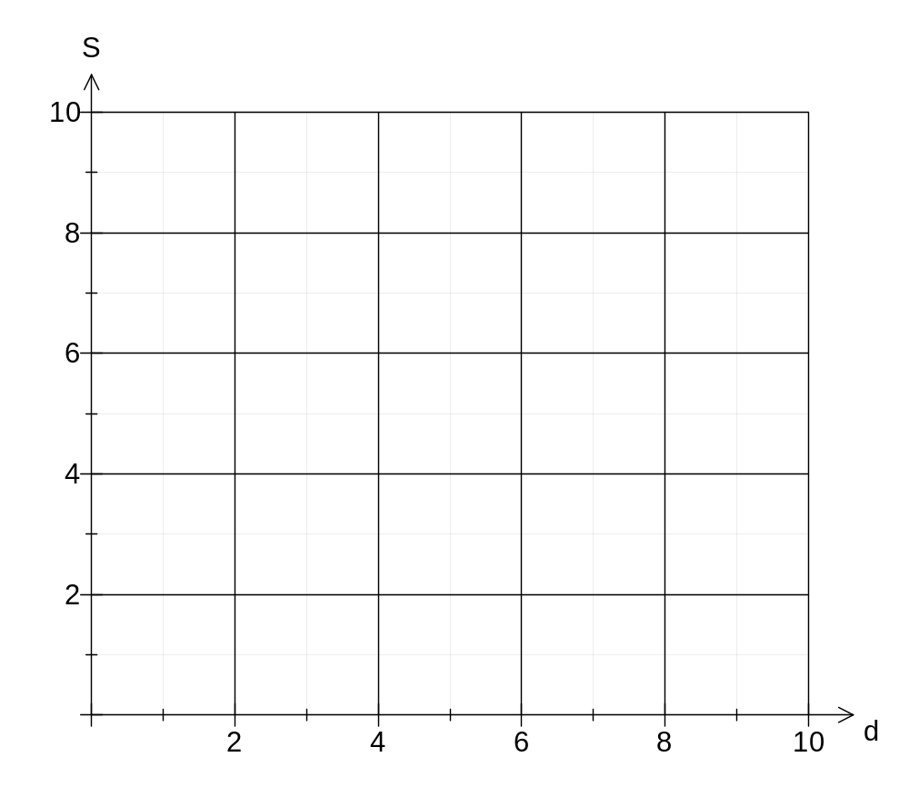

(d) The distance S run by Fiona on day d may be written in the form

Determine the value of:

(i) (1 mark)

(ii) (1 mark)

(e) Use the values you determined in part (d) above.

(i) Determine the value of d that corresponds to the value S = 9.0 (1 mark)

(ii) Explain why your solution to part (e) (i) is not reasonable in the situation of Fiona's training schedule. (1 mark)

Question 16 (5 marks)

An individual drink carton is designed in the shape of a rectangular prism with dimensions: height = 13 cm, width = 6 cm and depth 6 cm.
straw
A straight straw is taped on the side of the carton.

A hole is provided at the corner of the carton to insert the straw.
Drink

(a) What is the length, to the nearest centimetre, of the longest straight straw that does not project beyond the edges of the carton? (1 mark)

(b) If the dimensions of the carton are all doubled, how will that affect the length of the straw? (1 mark)

(c) A new type of straw is developed that can be folded before being taped to the carton. The straw can now be longer without projecting beyond the edges of the carton. The designers want the straw to be long enough that it cannot fall through the hole into the carton.

What is the minimum length required for the straw so that it will have at least 1 cm sticking out the drink carton when in use? (3 marks)

Question 17 (9 marks)

At a well-known wizard academy, students make pocket money by devising potions that are sold to other students.

A best-selling Elastica potion enables break-dancers to increase their flexibility on the dance floor. The recipe for Elastica requires 2 parts by weight of hogwash, 3 parts by weight of elixium, and 7 parts by weight of sugar.

(a) How much elixium is needed for 60 grams of Elastica potion? (2 marks)

(b) What percentage of Elastica is made of sugar? Give your answer correct to one decimal place. (2 marks)

The circle graph below illustrates the ingredients and proportions needed for Agoria potion.

The ingredients cost $84 to make 1 litre of this potion.
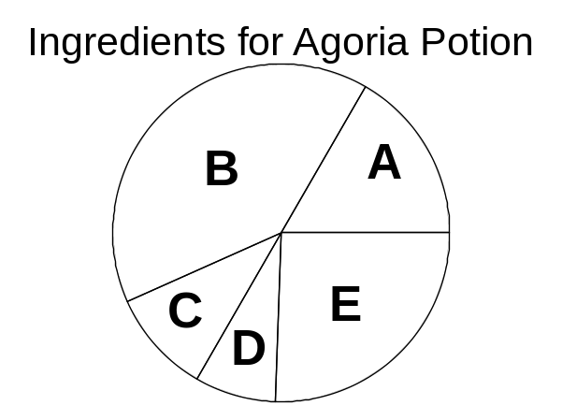
(c) Which two ingredients make up exactly half of Agoria potion? (1 mark)

(d) Ingredient A represents one-sixth of the circle graph. How much will it cost for ingredient A to make 500 mL of Agoria potion? (2 marks)

(e) Ingredient B costs $6.75 to make 200 mL of Agoria potion. What is the approximate percentage, correct to the nearest whole number, of ingredient B in Agoria potion?
(2 marks)

Question 18 (9 marks)

(a) Inigo saw that a hair-straightening appliance was advertised for a discount of 30%. If the usual price of the appliance is $46.99, what is the discounted price? (1 marks)

(b) At a second-hand caravan sale yard, a van that was purchased for $12 000 is then advertised for sale with a mark up of 40% added.

(i) At what price is the van advertised? (1 mark)

(ii) Clinton, a salesman, earned a 3% commission on the sale price of the van. If his commission was $480, for how much was the van sold? (1 marks)

(iii) Not only did the buyer of the van talk down the asking price, he also traded in his old vehicle for $1 500. What profit did the caravan sale yard actually make on the sale of this van? (2 marks)

(c) A stockbroker bought a penthouse for $1 940 000. After the global financial crisis he was forced to sell the penthouse for $1 720 000. The agent selling the penthouse received a commission of 1.5% of the selling price.

(i) How much did the stockbroker receive after the commission was paid?
(2 marks)

(ii) What was the stockbroker's loss on the sale of the penthouse expressed as a percentage of the price he paid to buy it, correct to one decimal place?
(2 marks)
Additional working space

Question number(s): __________

